Packrafting Awareness Presentation
- May 24th, 7-8:30 PM at the Murie Science and Learning Center
- June 5th, 7-8:30 PM at the Denali Education Center
- Beaver Sports in Fairbanks: June 12th, 6-7:30 PM
- REI Anchorage: August 1st, 6-7:30 PM

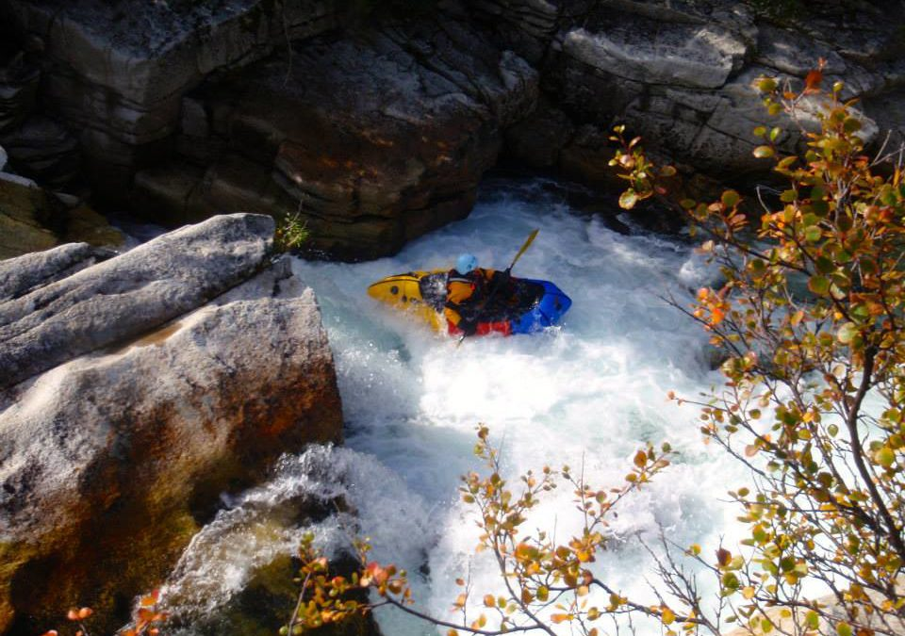

Monica Morin will be delivering multiple FREE Packrafting Awareness presentations to help prepare packrafting enthusiasts for this upcoming season. Mimicking Avalanche Awareness education, this hour and a half talk is an introduction to what you need to know prior to getting on the water.

